About final libraries and issue in RS :

**BACKGROUND SUBTRACTION.**

Well, in motion detection, we tend to make the following assumption:

**The background of our video stream is largely static and unchanging over consecutive frames of a video. Therefore, if we can model the background, we monitor it for substantial changes. If there is a substantial change, we can detect it — this change normally corresponds to motion on our video.**

**ABOUT PAKAGES USED IN CODES.**

1. **Imutils (**to make basic image processing tasks easier.)
2. **Cv2 (opencv)**
3. **Agrparse(**The **argparse** module makes it easy to write user-friendly command-line interfaces.)

**PAKAGES WHICH DIDN’T INSTALL IN RASPBRRY PI.**

The main issue to run code in raspbian system is to install opencv library.

Here I show u snap of the terminal of raspbian system

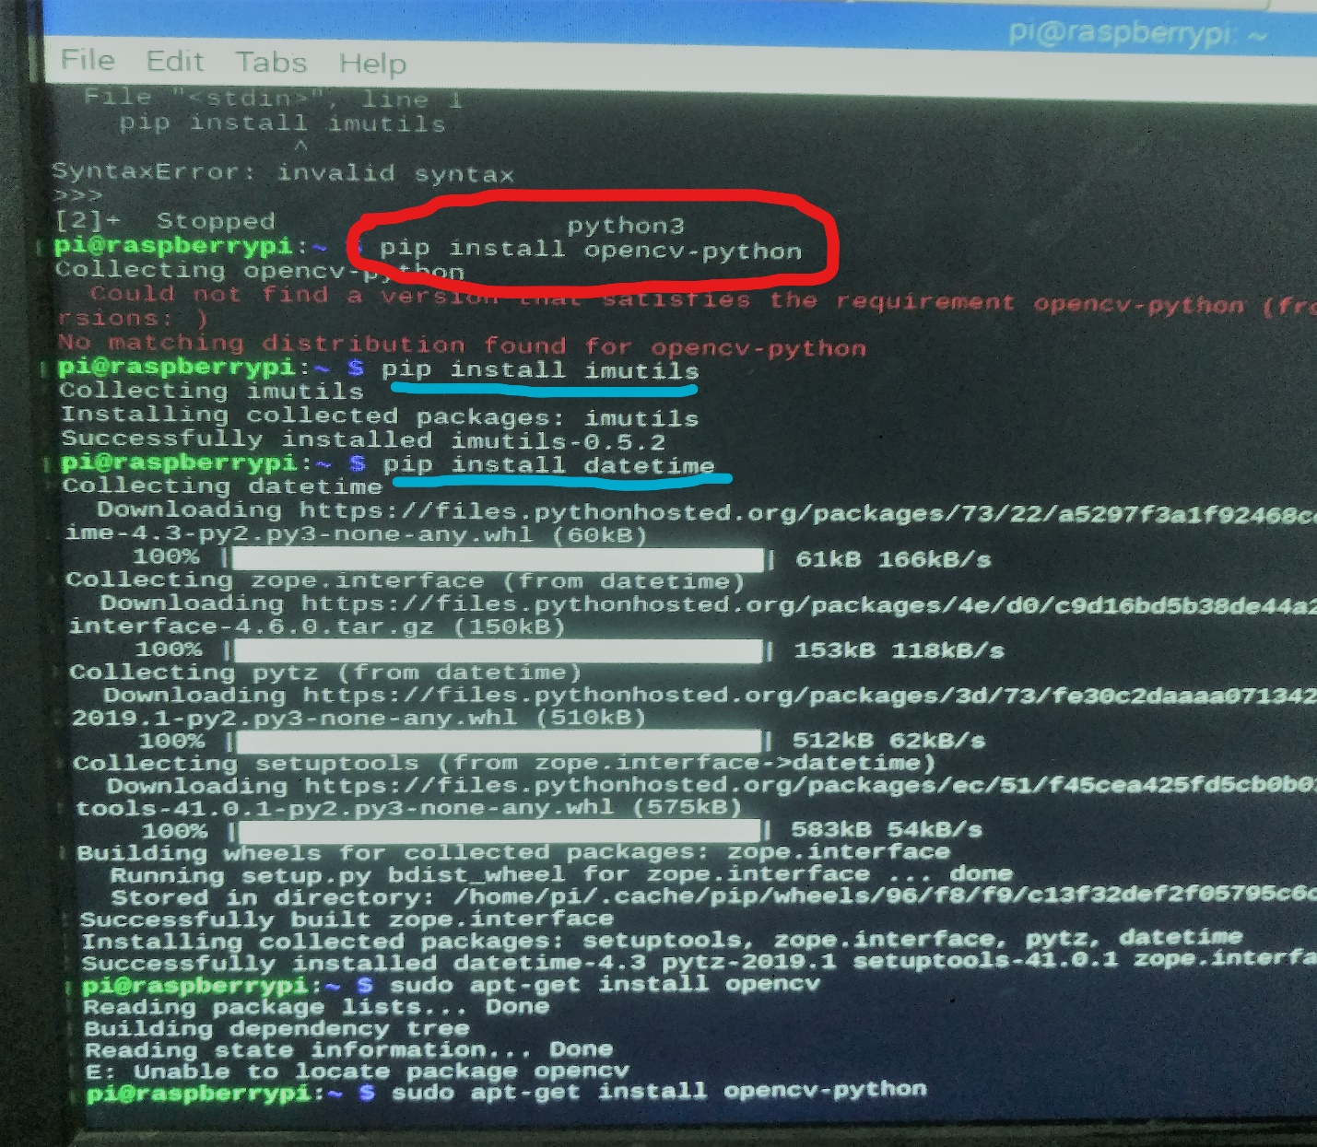

**The red marked one is a opencv library which didn’t install in terminal of RS.**

**To check whether other python libraries and packages are able to install or not. So, as u can see imutils and datetime is easily installed.(blue marked one)**

I also try “sudo apt “command to install open cv but it didn’t work. As u can see in snap (red marked one)

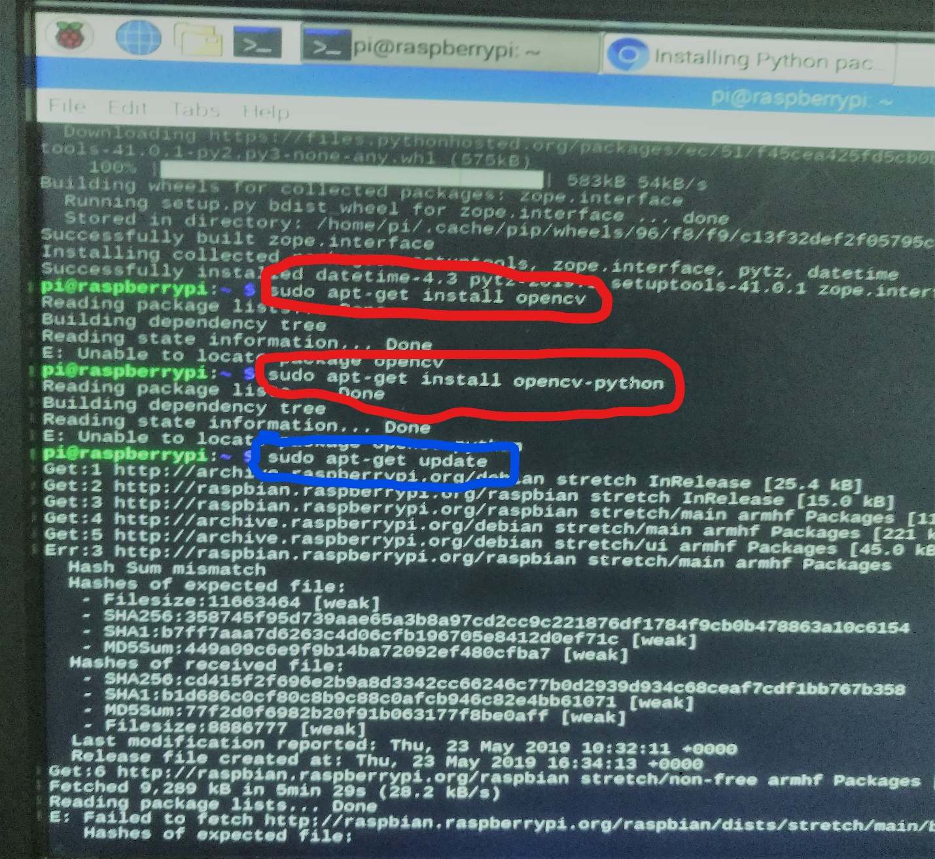

To check whether sudo apt works on terminal or not. U can see the blue marked on pic in which sudo apt works easily.

To run our program we need opencv library. To solve this issue, I also google it.

Here is a link (<https://www.learnopencv.com/install-opencv-4-on-raspberry-pi/>)

I also add some pics from which u have an idea that raspbian system takes to much time, steps and libraries to install

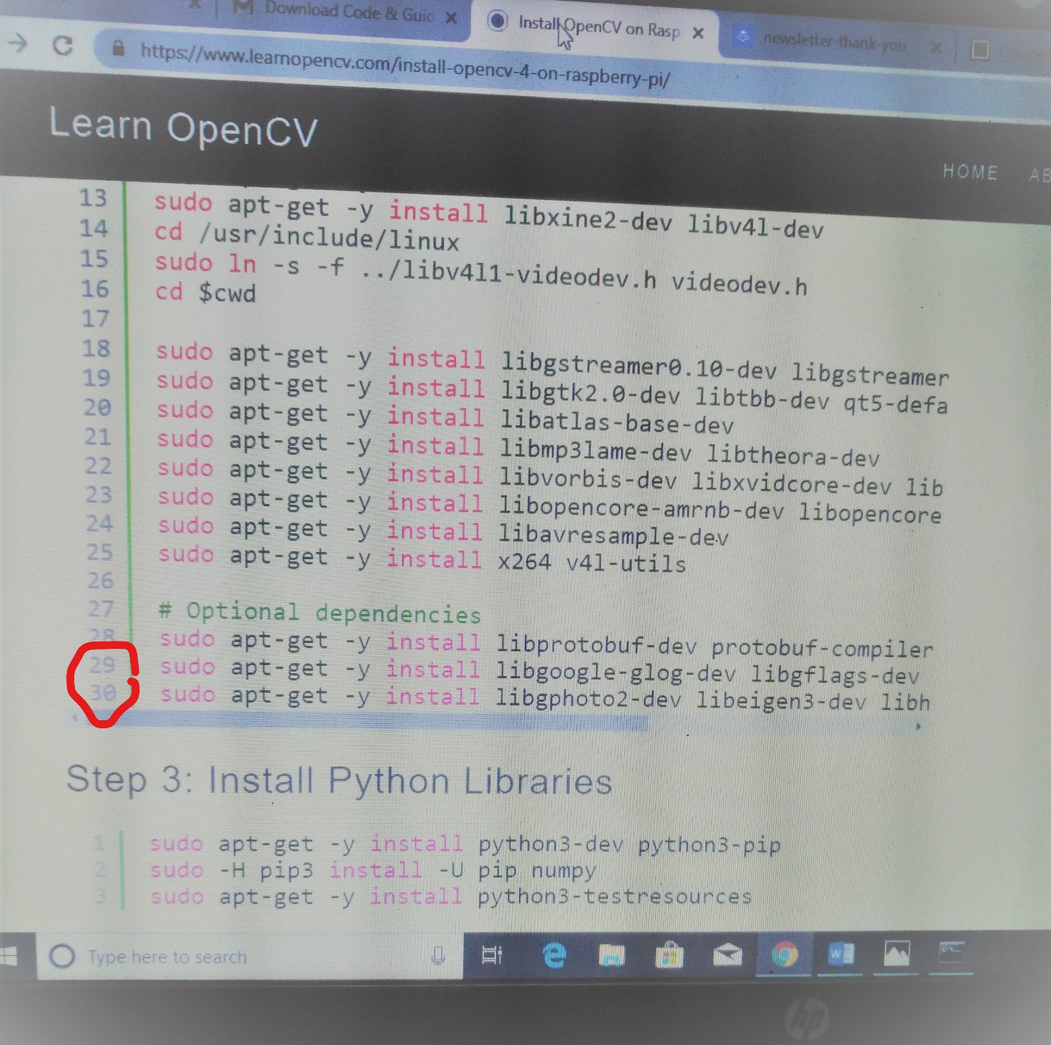

Almost every steps there is approx 30 commands to execute.

And total steps are:

